Can employment discrimination be justified on grounds of satisfying the preferences of customers? If so, under what circumstances? Does it make a difference whether the discrimination involves race or gender? Are there some consumer preferences that are morally illegitimate for a business to serve? If so, how should the law respond? Is it possible to determine what constitutes unjust employment discrimination without inquiring into the essential nature or purpose of the business?

Intro

Emplment disc just on grounds of prefer of customers, provided that the pref. are morally legitimate…

How should law respond? Aristotle: purpose of political communite to invite reflection not aggregate happiness. Not impossible to determine what constitutes unjust employment disc withot inquir into essence of business. … people should be a good *fit*. Discr based on anything other than fitness for the job is wrong.

_>> but maybe fitness reinforces stereotypes?

Robert Barro: utilitarian, “I believe the only mean- ingful measure of productivity is the amount a worker adds to customer satisfaction and to the happiness of co-workers. “

Ugly though?

--against; slippery slope argument. Ugly runs up against race, etc.

--For: essence of the job. They *are* models.

--For: too subjective to begin with (use quote)…too risky

Spellman

Is Hooter’s sex discrimination? Purpose of Hooters.

Advocates of change: No comparison between Hooters and playboy. Hooters is selling food.

Passell

Less hiring of unattractive people.

Cites Rhode Island law that gave $100,000 to 300 lb. woman because she was *perceived* as having a disability.

Gerlin

Females prefer female gynecologists, though males still account for the majority of doctors.

Diaz Vs. Pan-American World Airways

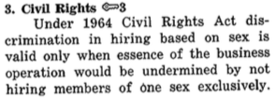

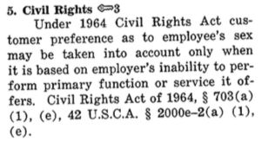

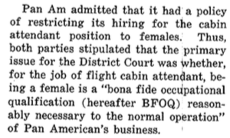

Do we have the right to determine the essence of a business? Does the law have that right? What about individual freedom of business owners? Aristotle. Contemplation. Law forms preferences. It has a formative role. See quote below. Morality.

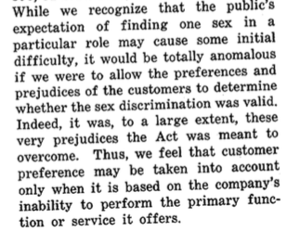

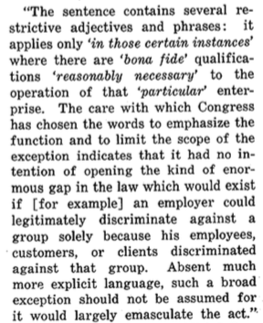

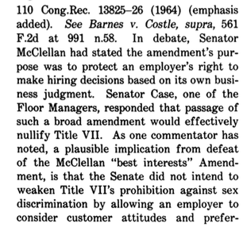

The question is: What if the business owner believes that hiring or not hiring a specific religion, race, sex, etc…will help his company?

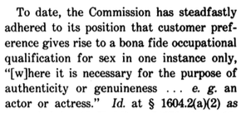

This is an example where nothing is wrong with the customer’s preferences…it is good for them to desire genuinen

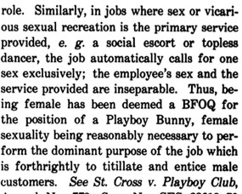ess.

Political community to form its *own* citizens…things get complicated when you form others:

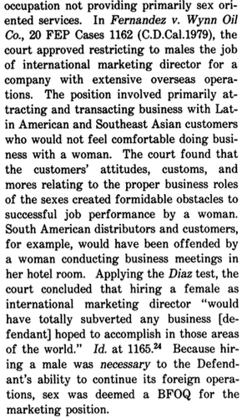

Brilliant:

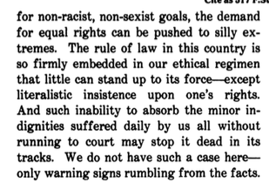

^^Hooters more closely resembles this warning than Airline stuff does, I think.

**POST**

Proponants of Santa Cruz ordinance:

1. Equality: look blind made everyone equal in some way

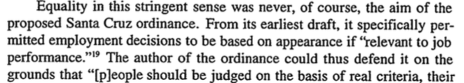

“relevant to job performance” <- proves essence of the thing matters

1. Personal Autonomy…I can have blue hair if I want and shouldn’t be controlled by employers

“The self determination of the employee must be set against the autonomy of the employer to present a particular image of her business.” (5)

Santa Cruz ordinance proscribed eventually discrimination based on things a person could control, such as tattoos, etc.

1. Fairness. Arbitrary discrimination based on physical characteristic.

American antidiscrimination law is *reduction ad absurdum* when applied to appearances?

Logic of antidisc law:

“Antidiscrimination law seeks to neutralize widespread forms of prejudice that pervasively disadvantage persons based upon inaccurate judgements about their worth or capacities.”

“Legal judgments of unfairness depend upon whether a stigmatizing attribute is viewed as somehow essential or integral to a person, as is their religion.”

“The point of rendering such factors [sex, race, religion, national origin] irrelevant is to “target” and eliminate “stubborn but irrational prejudice.”

“As a result, American antidiscrimination law typically requires employers, except in exceptional and discrete circumstances such as affirmative action, so make decisions as if their employees did not exhibit forbidden characteristic, as if, for example, employees had no race or sex.”

Post: “Each time the law adds another proscribed category of discrimination, it renders yet another attribute of employees invisible to their employers.”

…

“In what sense does a person without an appearance remain a person?”

🡪 Fitness for Aristotle…robbing women who are fit of their unique valued role in society.

Purpose of antidiscrimination law: to guarantee employers recognize “intrinsic worth” of employees. 🡪 But employers must distinguish between employees, as “intrinsic worth is by hypothesis equal”, so it must be something else.

It’s not individual worth, but an apprehension of individual *merit*, that the antidiscrimination law seeks to uncover.

“American antidiscrimination law pushes employers toward functional justifications for their actions.”

John Schaar criticized equality of opportunity as reducing a person to a bundle of abilities…Hooters reference.

Four aspects of antidisc logic:

1. instrumentalization of persons
2. distinguishes what’s intrinsically connected from what’s not
3. powerful and constructive, society-changing consequences (consider a quote pg. 16 for use of law transforming people)
4. audition screen is artificial and cannot carry the day without the willful adhesion of persons to the antidiscrimination sentiments.

^^^^ This *dominant conception* of American antidiscrimination law, distorts the masks of actual operation of that law,…undermines law’s coherence and usefulness as a tool of transofmrative social policy.”!!

Law singles out specific categories because these categories are systemized disadvantages in society… (17.)

The law itself is a social institution…does not arise in a vacuum of reason.

Dominant conception asks us to believe that the law can render certain categories truly irrelevant..CAN IT?

MAIN THRUST OF WHAT THE LAW TRULY IS: a social practice, which regulates other social practices, because the later have become for one reason or another controversial.

Dominant conception seeks to disestablish the category of sex and replace it with imperatives of functional rationality.

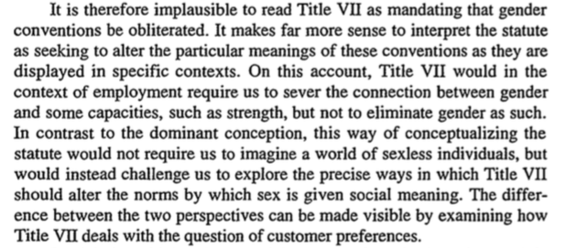

Functionality rationality in some circumstances actually reinforces traditional gender understandings!

By focusing the question of functional rationality on the narrow issue of the job performance of courier guards, instead of on the larger issue of the success of the business, the EEOC essentially insisted that the norm of sex blindness remain firmly attached to a concept of functional rationality.

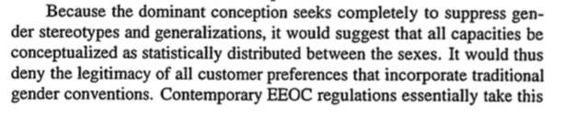

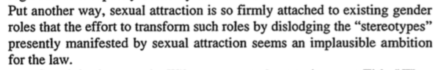

“The court [in the case of Southwest] implicitly acknowledge the limits of the law’s efforts to effect such transformations.”

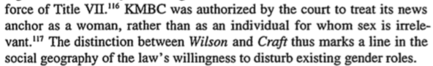

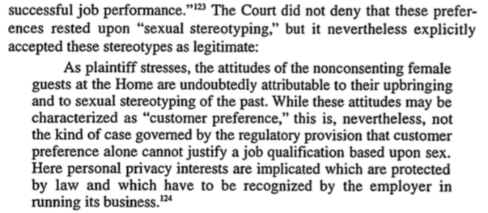

The court *can and should* incorporate stereotypes in some cases, as in the case of Fesel (nursing home). IN WHICH CASES SHOULD IT?

Title VII does not displace gender practices, but interacts with them in a special manner.

Interesting smmary of how the law interacts with existing gender norms:

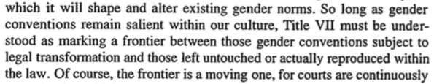

Sociological account, Post says, accepts the inevitability of social practices.

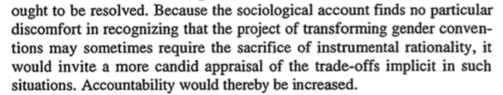

page 36, coherent doctrine

**Yuracko**

Sexual discrimination usually illegal, except:

Case in which sex based hiring necessary for sexual titillation for customers

Cases in which sex based necessary to protect privacy of customers.

“essence of the business”

*She argues no plausible conception of business “essence” can explain and make sense of the existing case law.*

*🡪 She quotes Post, who says that “the courts’ rhetoric of gender blindness does not explain their actual decisions in Title VII cases.” Rather, “Post argues that courts use Title VII not to eliminate gender as a social category, but to change its meaning in certain contexts and to eliminate sex-based sitinctions that are not justified by other widespread social values or norms.”*

*Yuracko: Nobody draws the line on why we permit certain sex-based discrimination but not others!*

*Court distinguishes between*

1. *Privacy (more sympathetic to this one)*
2. *Sexual Titillation (within this, they distinguish between selling only sexual titillation (sex), and “plus-sex” business.*

*🡪”How one determins the essence of a business is both facially unclear and radically undertheorized by the courts.”*

4 Possibilities:

1. essence as inherent meaning
2. Essence as shared social meaning
3. Essence as employer-defined
4. Essence as customer defined

Privacy cases do not raise the same slippery slope problems as sexual titillation cases.

“Perfectionists”: hold to good life conception, and contend that “government should encourage the values, activities, and ends that are consistent with these better ways of life and discourage those that are not.”

“Courts simply consider preferences for personal privacy to be more critical to one’s sense of dignity and identity than preferences for sexual titillation.”

Yuracko argues that this argument (perfectionist) is explicitly present in the courts’ own decisions.

Argues that court reluctant to permit sexiness and sexual titillation jobs for women because of a perfectionist desire to see more intellectual traits in women in the workplace.

Main point: to show incoherence and instability of the courts’ current BFOQ rhetoric. Seeks to provide a more thorough and consistent *basis* for the distinctions.

Employer defined theory: barber example…employer can shape his or her business.

Thoughts: it is right for court to distinguish between sexual titillation ( plus sex stuff) and explicitly selling sex. Why? because of the slippery slope argument.

WHO DETERMINES the eSSENCE? Must be answered.

Inherent theory: problematic because of Yuracko: 162: “As a result, one cannot define the essence of a business selling such goods merely by looking to the goods themselves.

**Shared-Meaning Theory of Essences**

EQUAL OPPORTUNITY norms are truly behind the courts decisions.

Thought: Of course we cannot allow businesses to define their essence in any way they want.

**Group-based** equaulity considerations truly behind courts decisions. Women and men should have equality opportunity as groups, and this rests on the assumption that there is nothing sex-based that can make job X more successful.

Explaining permissible sex-based discrimination: symmetry of exclusion.

**Hooters: use it as a lens?**

“In spite of these exceptions, sex-based hiring on behalf of customer privacy interests has a general symmetry of exclusion (and opportunity) that sex-based hiring for sexual titillation does not.”

Sex-based discrimination: slippery slope argument:

* difficult to see why “employers should not also be permitted to make hiring decisions based on their desire to sell not only a gendered type of sexuality but also a gendered type of allura or aura or even a particular kind of business ambience inextricably linked with workers of one sex or the other. Moreover, it is likely that the jobs linked directly or indicrectly to maleness, for which an employer may hire only men, will be of higher status and higher pay than the jobs linked directly to femaleness, for which an employer may hire only women.”

Slippery slope argument: “One employers are permitted to make hiring decisions in order to create a particular type of sexually charged atmosphere, it bcomes difficult to explain why employers should not also be permitted to make hiring decisions in order to cretate other kinds of oenvironments that are associated with or require the exclusive presence of one sex.”

Group-discrimination theory works well with the slippery slope version: “The true worry is that, potentially, the work world will become divided (as it once was) into distinctly male and distinctly female jobs in a way fundamentally antithetical to the goals of Title VII.”

Against the slippery slope argument: not as slippery, court still has power.

Court also recognizes some desires as more noble and better than others (not utilitarian!): desire for privacy better than sexual titillation.

“Also explicit in courts

COMMODIFY SEX (against prostitution…can of worms)

Weight preferences for sexual titillation against the importance of equal opportunity to jobs where sex is nonessential.

Perfectionist (Kantian?) view of individual preferences is a motivating factor for the courts.



Argument: It’s already marginalized! So will Hooters be.

Well, not so fast. Let’s keep marginalized away from non-marginalized. Purpose of law: to shape people: “The businesses must either become sex businesses, and accept the resulting social marginalization, or become nonsex business nd get rid of their explicit sexual-titillation dimension.”

**Worker-focused Perfectionism**

**🡪 Protect women’s ability to develop as intellectual and rational actors by carving out a space for them in the work world hwere they cannot be formally and explicitly sexualized.**

🡪 1. An emphasis on the importance for human flourishing of one’s self-development and social treatment as an intellectual reational actor

🡪 2. Recognition of the fragility of this valued self-conception

“It may be, however, that while human flourishing requires both intellectual and sexual development, italso requires a contextual disaggregation of the two. Human flourishing may require that sexual expression be confied to a particular social areas with other areas being virtual sex-free zones.”

Objection: Plus-sex jobs are most likely *not* to involve other forms of intellectual activity. No--“low wage and low-skill jobs”..still entail a “craft aspect”

Why: “The commodified versions threaten to make the *more valuable* noncommodified versions impossible.”

Sexuality crowd out women’s intellectual growth in the work world in 2 ways:

1. men won’t focus on women’s intellectual aspects
2. women *themselves* will join the party and overlook their own intellectual aspects.]

thus we should “minimize the jobs that explicitly combine cognitive and sexual requirements”

Under this perfectionist version, Hooters is actually *less dangerous,* she argues, to women than the Southwest airline. Why?

🡪 Hooters’ primary product is its sexualized environment

“Choice to be a Hooters Girl looks a lot like the choice to be a stripper.”

Should we allow such a thing? Will this create a non-sex free zone?

🡪 But southwest attendants had a clear set of cognitive, nonsexual responsibilities

Sexuality in the worldplace: It’s fine!!! But should be the agents making decisions for themselves…”employee-imposed”

Conclusion for Yuracko: